How to install aaBridge on Windows

See aaBridge on YouTube - Video 011 - Installing on Windows

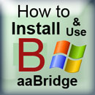
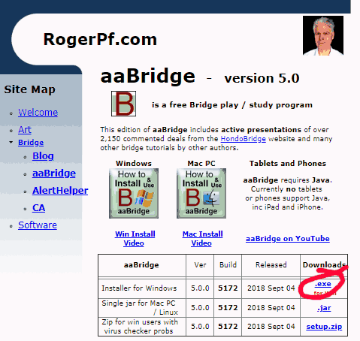

Go to
http://rogerpf.com/aaBridge

The page should look something like the image.

Click the .exe link shown ringed in red above.

The file with a name like aaBridge_5.0.0.5172_setup.exe
will now start to download.

<end of page>

Warnings Warnings Warnings – what are they all about ?

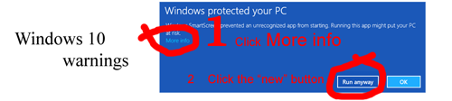

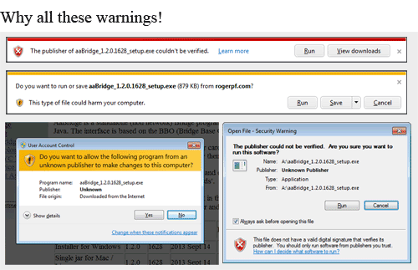
Your computer will warn you about installing aaBridge. This is sound advice you should not proceed unless you trust this software. This is true for any software you are installing. Did you get this document from a reputable place? Has it been recommend to you? Do you know people who use it?

Only proceed if you have decided that you trust the aaBridge program.

Choose Run or Save

A this point different browsers will ask different things. If you are offered a Run option choose that. If you only get offered Save then choose that. If your browser won't offer you either – time to use a different browser to do this.
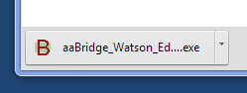
Chrome will instead always show the file downloading, icon in the bottom left. You can then click on it to run it or click the down-arrow then - Show in folder to see the downloads.

<end of page>
If you have previously selected the Save option, you now need to open your downloads folder and double click on the aaBridge.....exe file.

If you cannot see the .exe and .lin extensions on filenames (and you want to) then this how-to from Microsoft will show you how to see them.

http://windows.microsoft.com/en-us/windows/show-hide-file-name-extensions

Java
aaBridge will now be installing. At some point (possibly after a warning or two) if you have never installed Java (most people have) you will be whisked away in a browser to the Big corporate land of ORACLE and asked to install Java.


You will need to click the Free Java download button when you get shown it and jump through all the normal hoops. (Almost the same hoops you are jumping though to install aaBridge).

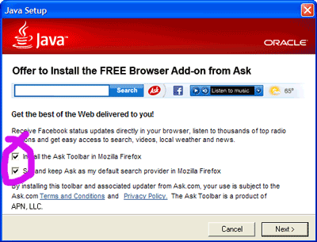
Take care when you get to

this screen >>>>

Uncheck whatever they are also trying to get you to install. Shown here in purple.

Tut-tut BIG Corporate – you should know better.


aaBridge will normally now launch for the first time. Whether it does not there will be an aaBridge icon on the desk top.

<end of page>
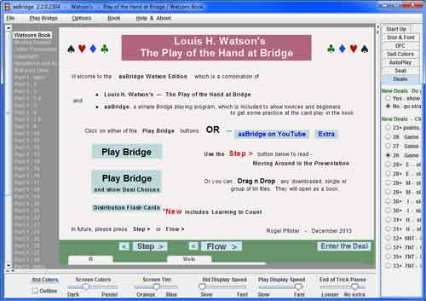
When aaBridge runs (you may need to Dbl Click the desktop icon) you will see a window like the one below.

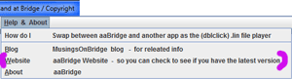
aaBridge is old fashioned in that the, check for new versions is done manually. Click on the menu item Help & About and click on the website option shown in the image with a purple markers.

Especially if you are a regular user it is worth checking every month or so.

If you are using aaBridge for the first time it you are advised to reader the Moving Around section see the grey column and look top left to click on it.

Drag & Drop to Play Bridge Movies
If you wish to use aaBridge to play Bridge Movies that you already have on your computer then – the way that will always work – is to go to the bridge movie folder on your computer. Then select a bridge movie and then drag & drop it on to an open aaBridge window like the one shown above.

<end of page>
Double Click to Play Bridge Movies
If you double click on a bridge movie that is already on your computer it will launch and play in aaBridge.

On Windows there is always a chance that another program will launch and try to run the .lin file (otherwise known as a bridge movie).

Choosing the program that plays lin files

If aaBridge does not launch when you double click on the bridge movie file then it may be because another program is currently selected to open .lin files.

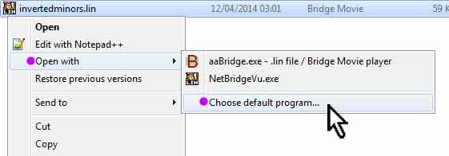
Point at an Bridge Movie (.lin file) with your mouse. Use the right mouse button to bring up the menu then select Open with and then click on Choose default program...

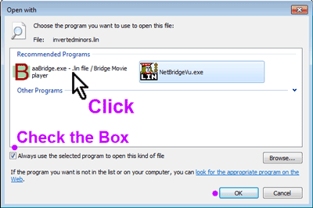
When the window opens select aaBridge and make sure that the checkbox is checked and click OK.

Your .lin file will then open in aaBridge and in future it will be aaBridge that is used to launch lin files when you double click or open movies via web links.

<end of page>
How to play Bridge Movies from on the Web

In your browser go to your favorite Bridge Site that has good Bridge Movies. Click on a Bridge movie link.

Different browsers do different things.

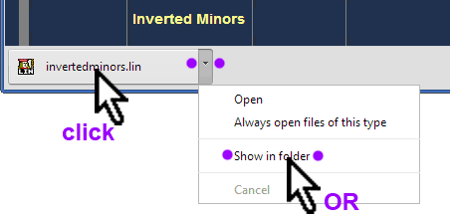
Chrome
On Chrome you get a moving image of the file in the bottom left as the file downloads.

Once it has fully arrived you can click on the icon/button
and it will launch.
OR
Click on the download drop box selector (purple dots) this will open your downloads folder where you can Click on - Show in folder.

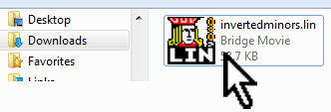
This will open the downloads folder. In this folder you can use the procedure given earlier to set aaBridge as the program that runs .lin files – Dbl Click to open.

Other Browsers
Some give you a choice between Open and Save, some only let you save. Open will do what you want and launch the lin file in your chosen lin file player. If you do a Save then again you want to show (go to) your downloads folder and there dbl-click the .lin file.

Last Resort
If that does not work! you can use the 'always works' method of dragging the new file from the downloads folder and dropping it on an open aaBridge window.
<end of page>

Hints on Using aaBridge

The navigation bar is the line of bumps, some of which may have characters on, which you can see at the bottom of the aaBridge screen.

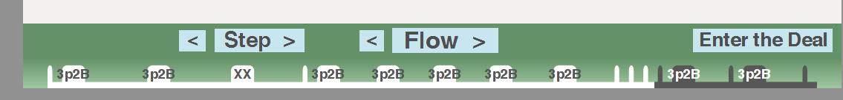
You can click anywhere on this line and you will be jumped immediately to that part of that bridge movie. The bumps represent markup points that the author has put into the file to give it some structure. With aaBridge you are not limited to just the bumps you can click between the bumps and jump to that position.

When you are in a book with multiple chapters, each chapter is its own bridge movie, then you will see in the grey bar on your left the names of each chapter. Click on one to jump there.

You can also use the forward and backwards arrows on your keyboard. When you get to the end of a chapter then the forward arrow will move you to the next chapter. The same applies if you are going backwards.

Step and Flow buttons

In a bridge movie's you move forward to the next stopping point, often called a page, by clicking on the Step and Flow buttons. Additionally, if can't play all bidding is being shown to you then the flow button will show each card will bid being played a very short pause after each.

You can set the duration of the pauses by using the time the sliders at the bottom of the screen, grab and raise the horizontal divider.

You are strongly encouraged to go through all the options. They were put there for you. Grab the vertical divider on the right and move it left.

<end of document>

